Secancy

Definition
# Source: AI Source: Provided by: [Data Path: Persons Table -> ID Column: 1, Name_En Column: Motasem Essam] -> From: [ChatGPT] on [7/25/2026]
Secancy is a geometric relationship in which a geometric object, especially a line or curve, intersects another geometric object at two or more distinct points.
For a line and a circle, a secant line passes through the circle and intersects its circumference at exactly two distinct points.
If the line is $l$and the circle is $C$, with intersection points $P$and $Q$:
$$\boxed{l∩C=\left\{P , Q\right\}}$$
where $P$and $Q$are the points of intersection.
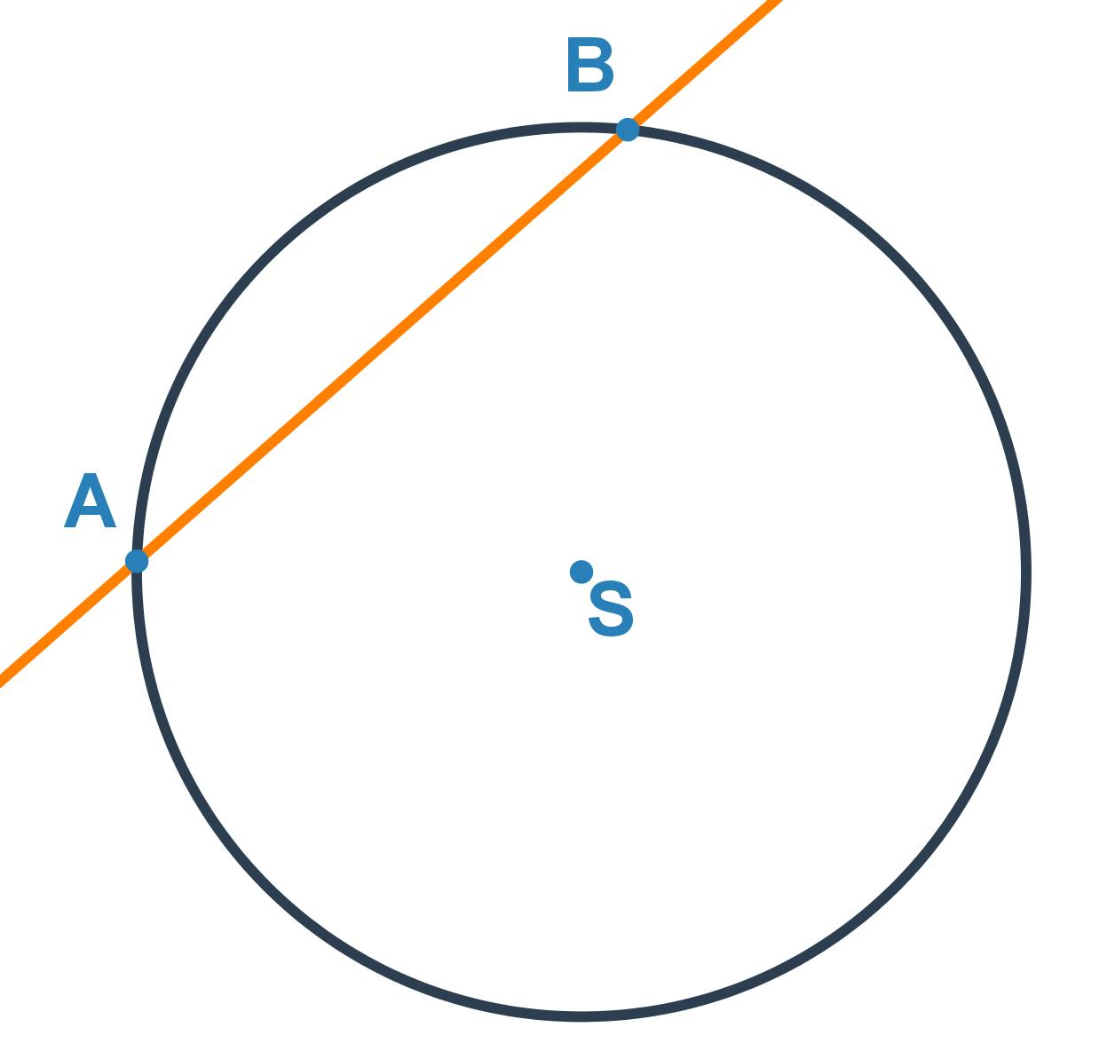
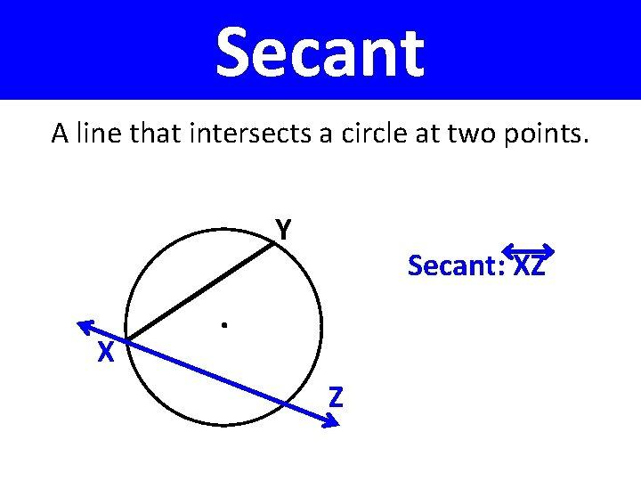
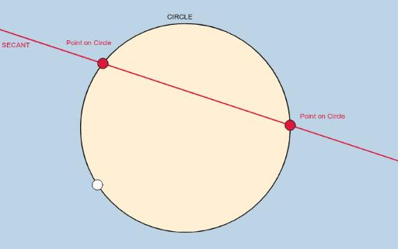

Purpose
# Source: AI Source: Provided by: [Data Path: Persons Table -> ID Column: 1, Name_En Column: Motasem Essam] -> From: [ChatGPT] on [7/25/2026]
Secancy is used to:
- Describe objects that intersect at multiple points.
- Analyze lines and circles.
- Determine the intersection of geometric objects.
- Study chords of circles.
- Calculate lengths involving secants.
- Apply the Secant–Secant Theorem.
- Apply the Secant–Tangent Theorem.
- Solve geometry and trigonometry problems.
- Analyze curves and their intersections.
- Study geometric relationships in coordinate geometry.
- Model intersections in CAD and computer graphics.

Fundamental Idea
# Source: AI Source: Provided by: [Data Path: Persons Table -> ID Column: 1, Name_En Column: Motasem Essam] -> From: [ChatGPT] on [7/25/2026]
The main idea of secancy is:
Intersection at two or more distinct points
For example:
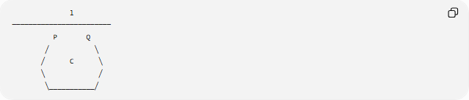
l
────────────────────────
P Q
╱ ╲
╱ C ╲
╲ ╱
╲___________╱
The line $l$passes through the circle $C$and intersects it at $P$and $Q$.
Therefore:
$$\boxed{l∩C=\left\{P , Q\right\}}$$
Unlike a tangent line, the secant line passes through the interior of the circle.

Secant Line
# Source: AI Source: Provided by: [Data Path: Persons Table -> ID Column: 1, Name_En Column: Motasem Essam] -> From: [ChatGPT] on [7/25/2026]
A secant line is a line that intersects a circle at two distinct points.
If $l$intersects circle $C$at $P$and $Q$:
$$\boxed{l∩C=\left\{P , Q\right\}}$$
The segment $PQ$is a chord of the circle.
Thus:
$$\boxed{\text{Secant line}→\text{Chord}}$$
A chord is the portion of a secant line lying inside the circle between its two intersection points.

Points of Intersection
# Source: AI Source: Provided by: [Data Path: Persons Table -> ID Column: 1, Name_En Column: Motasem Essam] -> From: [ChatGPT] on [7/25/2026]
The points where a secant intersects a circle are called the:
Points of Intersection
or:
Intersection Points
If the secant intersects the circle at $P$and $Q$:
$$P,Q=\text{points of intersection}$$
These points divide the secant line into portions that lie outside and inside the circle.

Secant and Chord Relationship
# Source: AI Source: Provided by: [Data Path: Persons Table -> ID Column: 1, Name_En Column: Motasem Essam] -> From: [ChatGPT] on [7/25/2026]
When a secant line passes through a circle, the portion between its two intersection points is a chord.
For example:
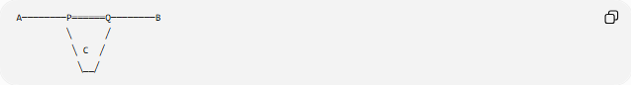
A────────P══════Q────────B
╲ ╱
╲ C ╱
╲__╱
Here:
- $AB$is the secant line.
- $P$and $Q$are the intersection points.
- $PQ$is the chord.
- $AP$and $QB$are external portions of the secant.
Therefore:
$$\boxed{PQ=\text{chord}}$$

Secant vs. Tangent
# Source: AI Source: Provided by: [Data Path: Persons Table -> ID Column: 1, Name_En Column: Motasem Essam] -> From: [ChatGPT] on [7/25/2026]
A secant line intersects a circle at two points, while a tangent line touches the circle at exactly one point.
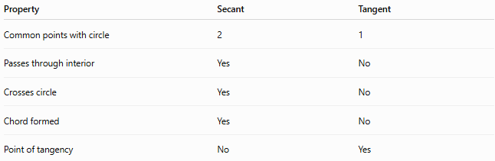
Property | Secant | Tangent
Common points with circle | 2 | 1
Passes through interior | Yes | No
Crosses circle | Yes | No
Chord formed | Yes | No
Point of tangency | No | Yes
Therefore:
$$\boxed{\text{Secant}→2\text{ points}}$$
and:
$$\boxed{\text{Tangent}→1\text{ point}}$$

Secant vs. Non-Intersecting Line
# Source: AI Source: Provided by: [Data Path: Persons Table -> ID Column: 1, Name_En Column: Motasem Essam] -> From: [ChatGPT] on [7/25/2026]
A line and a circle can have three basic relationships:
1. No Intersection
The line does not meet the circle:
$$\boxed{l∩C=∅}$$
Number of intersection points:
$$\boxed{0}$$
2. Tangency
The line touches the circle at exactly one point:
$$\boxed{l∩C=\left\{P\right\}}$$
Number of intersection points:
$$\boxed{1}$$
3. Secancy
The line crosses the circle at two points:
$$\boxed{l∩C=\left\{P , Q\right\}}$$
Number of intersection points:
$$\boxed{2}$$

Secancy and Distance
# Source: AI Source: Provided by: [Data Path: Persons Table -> ID Column: 1, Name_En Column: Motasem Essam] -> From: [ChatGPT] on [7/25/2026]
The perpendicular distance from the center of a circle to a line determines whether the line is a secant, tangent, or non-intersecting line.
For a circle with radius $r$, let:
$$d=d\left(O , l\right)$$
where $O$is the center and $l$is the line.
Secant
If:
$$\boxed{d<r}$$
the line passes through the circle and is a secant.
Tangent
If:
$$\boxed{d=r}$$
the line touches the circle and is tangent.
No Intersection
If:
$$\boxed{d>r}$$
the line does not intersect the circle.
Therefore:
$$\boxed{\begin{matrix}d<r & \text{Secant} \\ d=r & \text{Tangent} \\ d>r & \text{No Intersection}\end{matrix}}$$

Coordinate Geometry
# Source: AI Source: Provided by: [Data Path: Persons Table -> ID Column: 1, Name_En Column: Motasem Essam] -> From: [ChatGPT] on [7/25/2026]
Consider a circle with center:
$$O=\left(x_{0} , y_{0}\right)$$
and radius $r$.
Consider the line:
$$Ax+By+C=0$$
The perpendicular distance from the center to the line is:
$$d=\frac{∣Ax_{0}+By_{0}+C∣}{\sqrt{A^{2}+B^{2}}}$$
The line is a secant when:
$$\boxed{\frac{∣Ax_{0}+By_{0}+C∣}{\sqrt{A^{2}+B^{2}}}<r}$$
because the line passes through the interior of the circle.

Coordinate Example
# Source: AI Source: Provided by: [Data Path: Persons Table -> ID Column: 1, Name_En Column: Motasem Essam] -> From: [ChatGPT] on [7/25/2026]
Consider the circle:
$$x^{2}+y^{2}=25$$
Its center is:
$$O=\left(0 , 0\right)$$
and its radius is:
$$r=5$$
Consider the line:
$$y=3$$
Written in standard form:
$$y-3=0$$
The distance from the center to the line is:
$$d=\frac{∣0-3∣}{1}=3$$
Since:
$$d<r$$
we have:
$$3<5$$
Therefore, the line passes through the circle at two points.
Thus:
$$\boxed{y=3\text{ is a secant of }x^{2}+y^{2}=25}$$
The intersection points can be found by substituting $y=3$:
$$x^{2}+3^{2}=25 \\ x^{2}+9=25 \\ x^{2}=16 \\ x=±4$$
Therefore, the two points of intersection are:
$$\boxed{P=\left(- , 43\right), Q=\left(4 , 3\right)}$$

Secant Segment
# Source: AI Source: Provided by: [Data Path: Persons Table -> ID Column: 1, Name_En Column: Motasem Essam] -> From: [ChatGPT] on [7/25/2026]
A secant segment is a portion of a secant line that intersects a circle at two points.
For:
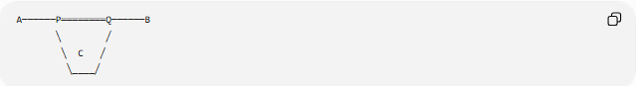
A──────P════════Q──────B
╲ ╱
╲ C ╱
╲____╱
the segment $AB$is a secant segment, while $PQ$is the chord.
The portions:
$$AP$$
and:
$$BQ$$
are external secant segments.

Secant–Secant Theorem
# Source: AI Source: Provided by: [Data Path: Persons Table -> ID Column: 1, Name_En Column: Motasem Essam] -> From: [ChatGPT] on [7/25/2026]
When two secant lines are drawn from an external point and intersect a circle, the product of the lengths of the external segment and the entire secant segment is equal for both secants.
Suppose two secants from external point $P$intersect the circle at:
$$A,B$$
and:
$$C,D$$
Then:
$$\boxed{PA⋅PB=PC⋅PD}$$
where:
- $PA$and $PC$are the external segments.
- $PB$and $PD$are the entire secant segments.

Secant–Secant Example
# Source: AI Source: Provided by: [Data Path: Persons Table -> ID Column: 1, Name_En Column: Motasem Essam] -> From: [ChatGPT] on [7/25/2026]
Suppose two secants are drawn from an external point $P$.
For the first secant:
$$PA=4$$
and:
$$PB=12$$
For the second secant:
$$PC=6$$
and:
$$PD=x$$
Using the Secant–Secant Theorem:
$$PA⋅PB=PC⋅PD$$
Substitute:
$$4\left(12\right)=6x \\ 48=6x$$
Therefore:
$$\boxed{x=8}$$

Secant–Tangent Theorem
# Source: AI Source: Provided by: [Data Path: Persons Table -> ID Column: 1, Name_En Column: Motasem Essam] -> From: [ChatGPT] on [7/25/2026]
When a tangent and a secant are drawn from the same external point to a circle, the square of the tangent length equals the product of the external secant segment and the entire secant segment.
If $PT$is tangent to the circle and $PAB$is a secant:
$$\boxed{PT^{2}=PA⋅PB}$$
where:
- $PT$is the tangent segment.
- $PA$is the external secant segment.
- $PB$is the entire secant segment.

Secant–Tangent Example
# Source: AI Source: Provided by: [Data Path: Persons Table -> ID Column: 1, Name_En Column: Motasem Essam] -> From: [ChatGPT] on [7/25/2026]
Suppose:
$$PA=4$$
and:
$$PB=16$$
A tangent $PT$is drawn from the same external point.
Using:
$$PT^{2}=PA⋅PB$$
we obtain:
$$PT^{2}=4\left(16\right) \\ PT^{2}=64$$
Therefore:
$$\boxed{PT=8}$$

Secancy and Circle Intersection
# Source: AI Source: Provided by: [Data Path: Persons Table -> ID Column: 1, Name_En Column: Motasem Essam] -> From: [ChatGPT] on [7/25/2026]
For a circle and a line, secancy occurs when the line intersects the circle at two distinct points.
The three cases are:
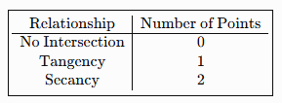
$$\boxed{\begin{matrix}\text{Relationship} & \text{Number of Points} \\ \text{No Intersection} & 0 \\ \text{Tangency} & 1 \\ \text{Secancy} & 2\end{matrix}}$$
This provides a simple classification of the relationship between a line and a circle.

Secancy Between Two Curves
# Source: AI Source: Provided by: [Data Path: Persons Table -> ID Column: 1, Name_En Column: Motasem Essam] -> From: [ChatGPT] on [7/25/2026]
Secancy can also be considered for curves.
Two curves are secant to each other when they intersect at distinct points rather than merely touching at a single point.
For example, if curves $f$and $g$intersect at $P$and $Q$:
$$\boxed{f∩g=\left\{P , Q\right\}}$$
The curves have two distinct common points.
If the curves cross at these points, their tangent directions may be different at the intersections.

Secancy vs. Tangency of Curves
# Source: AI Source: Provided by: [Data Path: Persons Table -> ID Column: 1, Name_En Column: Motasem Essam] -> From: [ChatGPT] on [7/25/2026]
For two curves:
Tangency
The curves meet at a point and have the same tangent direction there.
At $x=x_{0}$:
$$f\left(x_{0}\right)=g\left(x_{0}\right)$$
and, when derivatives exist:
$$f^{'}\left(x_{0}\right)=g^{'}\left(x_{0}\right)$$
Secant Intersection
The curves intersect at distinct points, such as $P$and $Q$:
$$\boxed{f∩g=\left\{P , Q\right\}}$$
Thus, secancy describes multiple intersections, while tangency describes contact without crossing at the contact point.

Secancy and Circle Chords
# Source: AI Source: Provided by: [Data Path: Persons Table -> ID Column: 1, Name_En Column: Motasem Essam] -> From: [ChatGPT] on [7/25/2026]
Every secant line that intersects a circle at two points determines a chord.
If the secant intersects the circle at $P$and $Q$, then:
$$\boxed{PQ=\text{chord}}$$
The chord is the finite portion of the secant line contained within the circle.
Therefore:
$$\boxed{\text{Secant line}⊃\text{Chord}}$$

Secancy in Circle Geometry
# Source: AI Source: Provided by: [Data Path: Persons Table -> ID Column: 1, Name_En Column: Motasem Essam] -> From: [ChatGPT] on [7/25/2026]
Secants are important in circle geometry because they provide relationships between:
- Chords.
- Arcs.
- Angles.
- External segments.
- Tangent segments.
- Circle intersections.
Secant lines are especially important in theorems involving lengths and angles formed outside or inside circles.

Secant Angles
# Source: AI Source: Provided by: [Data Path: Persons Table -> ID Column: 1, Name_En Column: Motasem Essam] -> From: [ChatGPT] on [7/25/2026]
Secants can form angles involving circles.
For example, when two secants intersect outside a circle, the measure of the external angle can be determined using the intercepted arcs.
For two secants from an external point:
$$\boxed{m∠P=\frac{1}{2}\left(\text{measure of larger intercepted arc}-\text{measure of smaller intercepted arc}\right)}$$
This is known as the external secant angle relationship.

Secancy in Coordinate Geometry
# Source: AI Source: Provided by: [Data Path: Persons Table -> ID Column: 1, Name_En Column: Motasem Essam] -> From: [ChatGPT] on [7/25/2026]
Secancy can be determined by solving the equations of the two geometric objects simultaneously.
For a circle:
$${\left(x-h\right)}^{2}+{\left(y-k\right)}^{2}=r^{2}$$
and a line:
$$y=mx+b$$
substituting the line equation into the circle equation produces a quadratic equation.
The discriminant determines the relationship:
$$\boxed{Δ>0→\text{Secant}} \\ \boxed{Δ=0→\text{Tangent}} \\ \boxed{Δ<0→\text{No real intersection}}$$
Thus, a positive discriminant corresponds to two distinct real intersection points.

Secancy in Architecture and Engineering
# Source: AI Source: Provided by: [Data Path: Persons Table -> ID Column: 1, Name_En Column: Motasem Essam] -> From: [ChatGPT] on [7/25/2026]
Secant relationships can appear when geometric elements intersect one another.
Examples include:
- Structural lines crossing curved elements.
- Roads crossing circular or curved boundaries.
- Mechanical components intersecting at multiple points.
- Engineering drawings containing intersecting curves.
- Geometric construction and measurement.

Secancy in CAD
# Source: AI Source: Provided by: [Data Path: Persons Table -> ID Column: 1, Name_En Column: Motasem Essam] -> From: [ChatGPT] on [7/25/2026]
CAD systems use intersections between lines, circles, arcs, and curves to construct and analyze geometric objects.
A secant relationship may be used when:
- A line intersects a circle.
- An arc intersects another curve.
- Two curves have multiple intersection points.
- Geometric boundaries are divided at intersection points.
- Construction geometry is created from intersecting objects.

Secancy in Computer Graphics
# Source: AI Source: Provided by: [Data Path: Persons Table -> ID Column: 1, Name_En Column: Motasem Essam] -> From: [ChatGPT] on [7/25/2026]
Secant intersections are used in computer graphics and computational geometry to determine where geometric objects meet.
Applications include:
- Curve intersection.
- Shape construction.
- Boundary detection.
- Collision calculations.
- Geometric modeling.
- Vector graphics.
- CAD systems.
- Path and curve analysis.

Real-World Examples
# Source: AI Source: Provided by: [Data Path: Persons Table -> ID Column: 1, Name_En Column: Motasem Essam] -> From: [ChatGPT] on [7/25/2026]
Secant relationships can be illustrated by:
- A straight line passing through a circular object.
- A rod passing through a circular opening.
- A road crossing a circular boundary at two locations.
- A line drawn through a circular disk.
- A chord of a circular object together with its extended line.
- Two curved boundaries crossing at multiple points.

Applications
# Source: AI Source: Provided by: [Data Path: Persons Table -> ID Column: 1, Name_En Column: Motasem Essam] -> From: [ChatGPT] on [7/25/2026]
Secancy is important in:
- Plane Geometry
- Circle Geometry
- Euclidean Geometry
- Coordinate Geometry
- Trigonometry
- Calculus
- Analytical Geometry
- CAD
- Computer Graphics
- Computational Geometry
- Architecture
- Engineering
- Mechanical Design

Advantages
# Source: AI Source: Provided by: [Data Path: Persons Table -> ID Column: 1, Name_En Column: Motasem Essam] -> From: [ChatGPT] on [7/25/2026]
Studying secancy helps to:
- Identify multiple intersections.
- Analyze lines and circles.
- Determine chord lengths.
- Apply circle theorems.
- Calculate unknown lengths.
- Analyze angles formed by secants.
- Solve coordinate-geometry problems.
- Understand the relationship between secants and tangents.
- Model intersections in CAD and computer graphics.

Limitations
# Source: AI Source: Provided by: [Data Path: Persons Table -> ID Column: 1, Name_En Column: Motasem Essam] -> From: [ChatGPT] on [7/25/2026]
Secancy:
- Requires distinct intersection points.
- Must be distinguished from tangency.
- May require algebraic calculations to determine intersections.
- Can be difficult to identify from approximate drawings.
- May involve solving quadratic or higher-degree equations.
- In computer systems, numerical errors can make very close intersections difficult to classify.
- Does not by itself describe the angle or nature of every intersection.

Comparison with Related Concepts
# Source: AI Source: Provided by: [Data Path: Persons Table -> ID Column: 1, Name_En Column: Motasem Essam] -> From: [ChatGPT] on [7/25/2026]
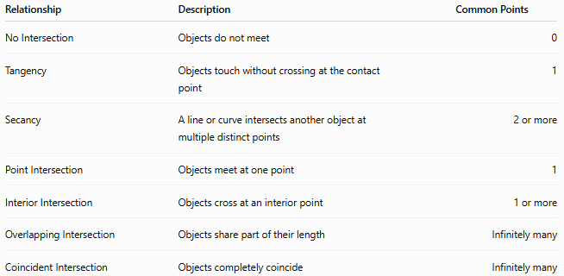
Relationship | Description | Common Points
No Intersection | Objects do not meet | 0
Tangency | Objects touch without crossing at the contact point | 1
Secancy | A line or curve intersects another object at multiple distinct points | 2 or more
Point Intersection | Objects meet at one point | 1
Interior Intersection | Objects cross at an interior point | 1 or more
Overlapping Intersection | Objects share part of their length | Infinitely many
Coincident Intersection | Objects completely coincide | Infinitely many
For a line and circle specifically:
$$\boxed{0=\text{No Intersection}, 1=\text{Tangency}, 2=\text{Secancy}}$$

Key Points
# Source: AI Source: Provided by: [Data Path: Persons Table -> ID Column: 1, Name_En Column: Motasem Essam] -> From: [ChatGPT] on [7/25/2026]
- Secancy describes a geometric relationship involving two or more distinct intersection points.
- A secant line intersects a circle at exactly two distinct points.
- The two intersection points are commonly denoted $P$and $Q$.
- The portion of a secant between the two intersection points is a chord.
- For a circle of radius $r$, a line is secant when:
$$\boxed{d<r}$$
- A tangent line has one intersection point:
$$\boxed{d=r}$$
- A non-intersecting line has zero intersection points:
$$\boxed{d>r}$$
- The Secant–Secant Theorem states:
$$\boxed{PA⋅PB=PC⋅PD}$$
- The Secant–Tangent Theorem states:
$$\boxed{PT^{2}=PA⋅PB}$$
- In coordinate geometry, a positive quadratic discriminant indicates two distinct real intersections.
- Secancy is widely used in circle geometry, coordinate geometry, engineering, CAD, and computer graphics.

Conclusion
# Source: AI Source: Provided by: [Data Path: Persons Table -> ID Column: 1, Name_En Column: Motasem Essam] -> From: [ChatGPT] on [7/25/2026]
Secancy is a geometric relationship in which a line or curve intersects another geometric object at two or more distinct points. In the most familiar case, a secant line passes through a circle and intersects its circumference at exactly two points. The portion of the secant between these points forms a chord. Secants are closely related to tangents, but a secant crosses through the circle while a tangent touches it at exactly one point. Secancy is also fundamental to the Secant–Secant Theorem and Secant–Tangent Theorem and is widely used in circle geometry, coordinate geometry, analytical geometry, CAD, engineering, architecture, and computer graphics.

